**Terraform Final Task.**

1.Create VPC

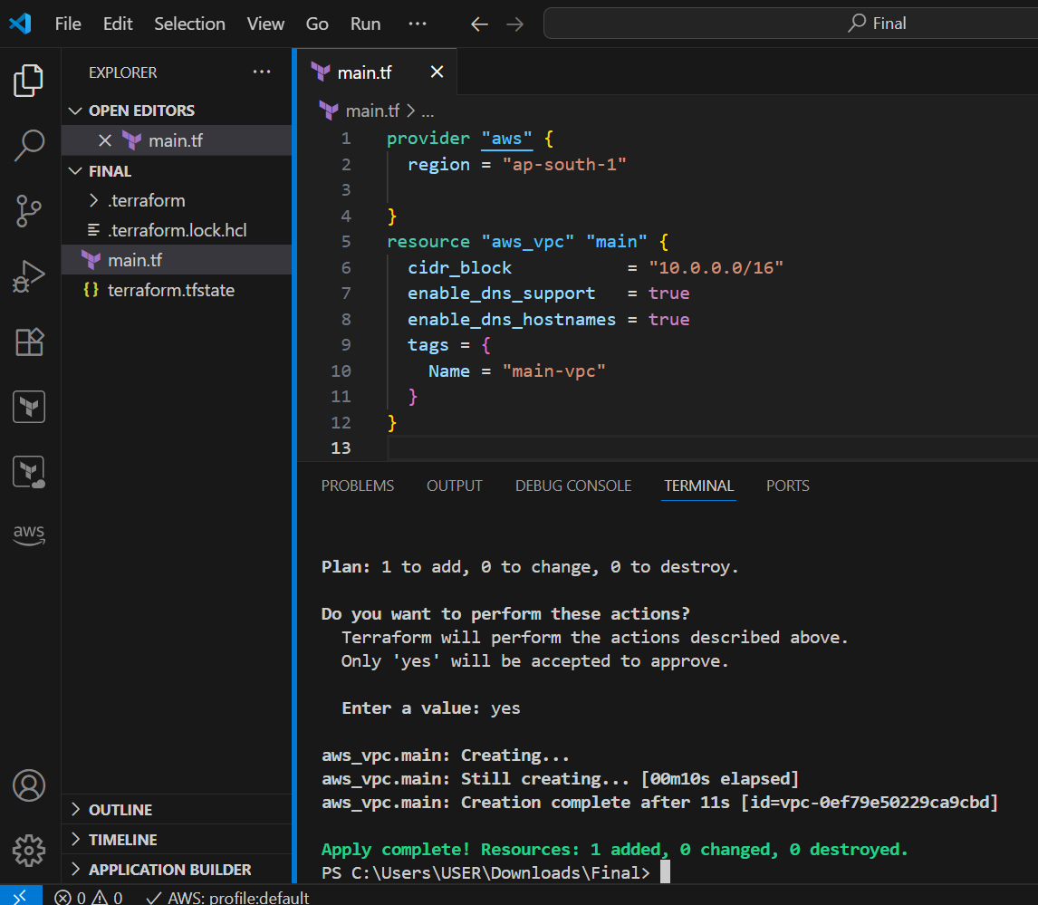

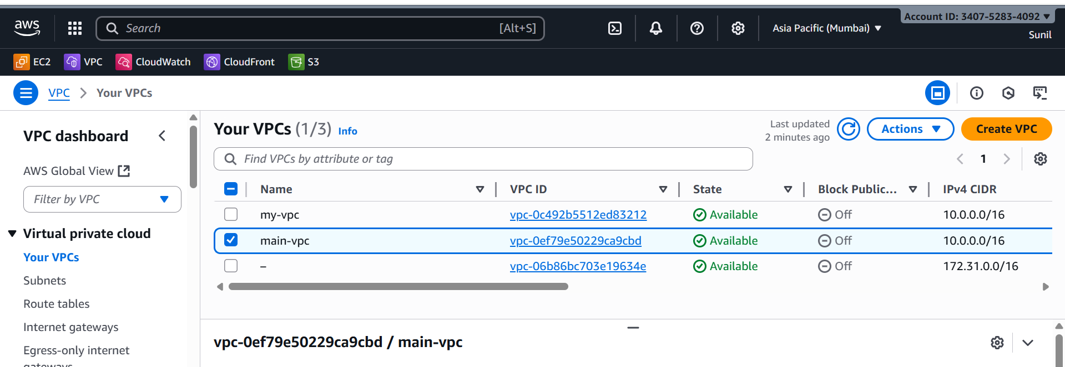

2.Create Internet gateway

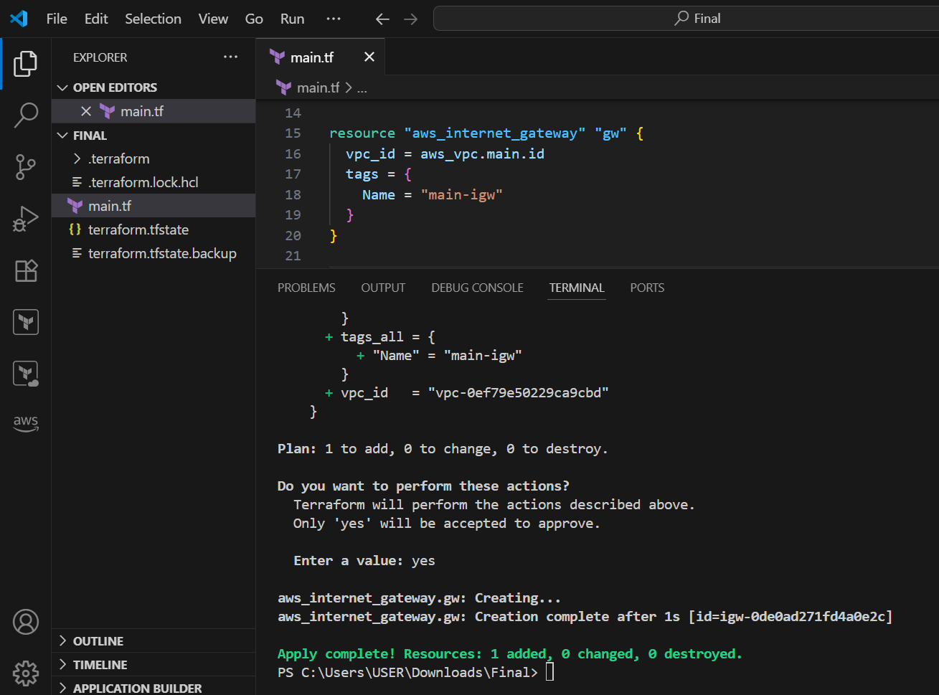

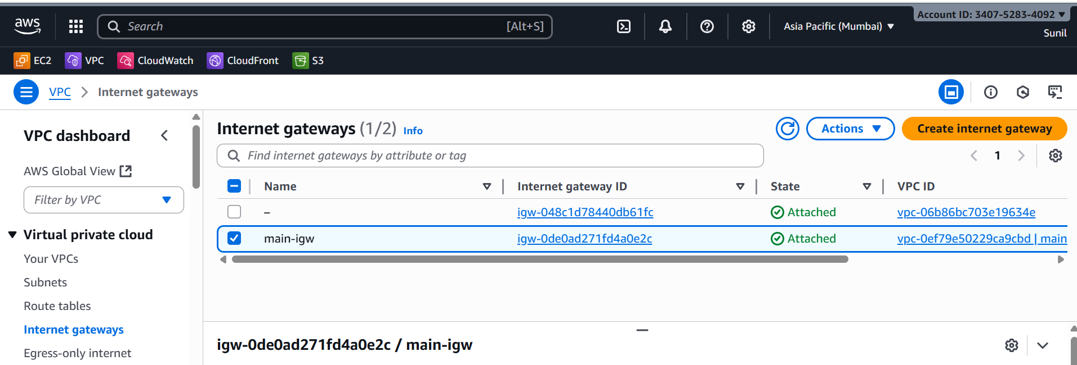

3.Create Custom Route Table

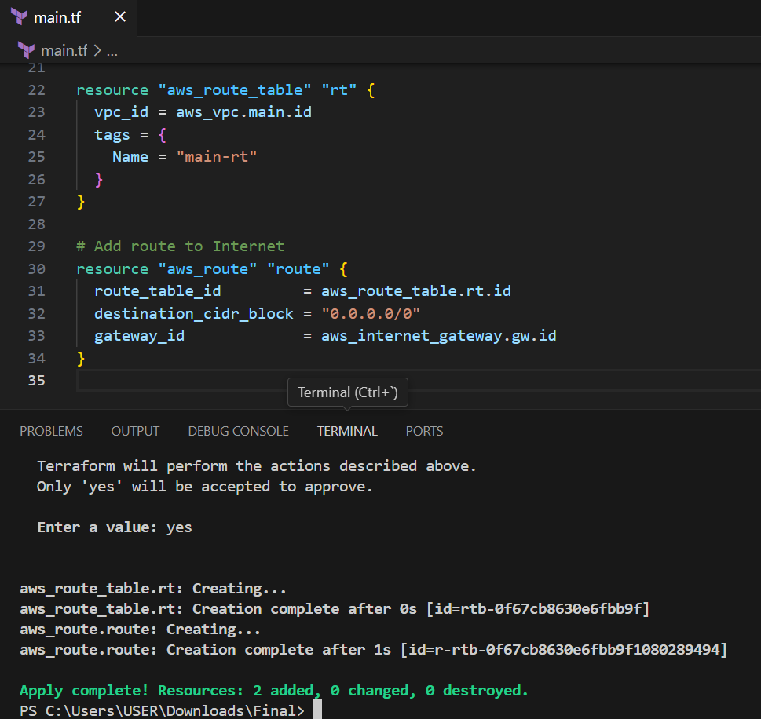

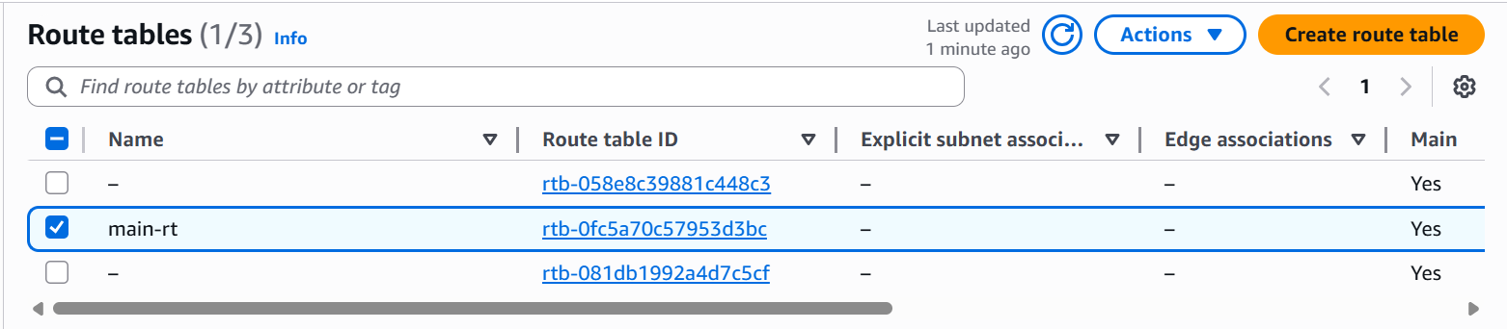

4.Create Subnet

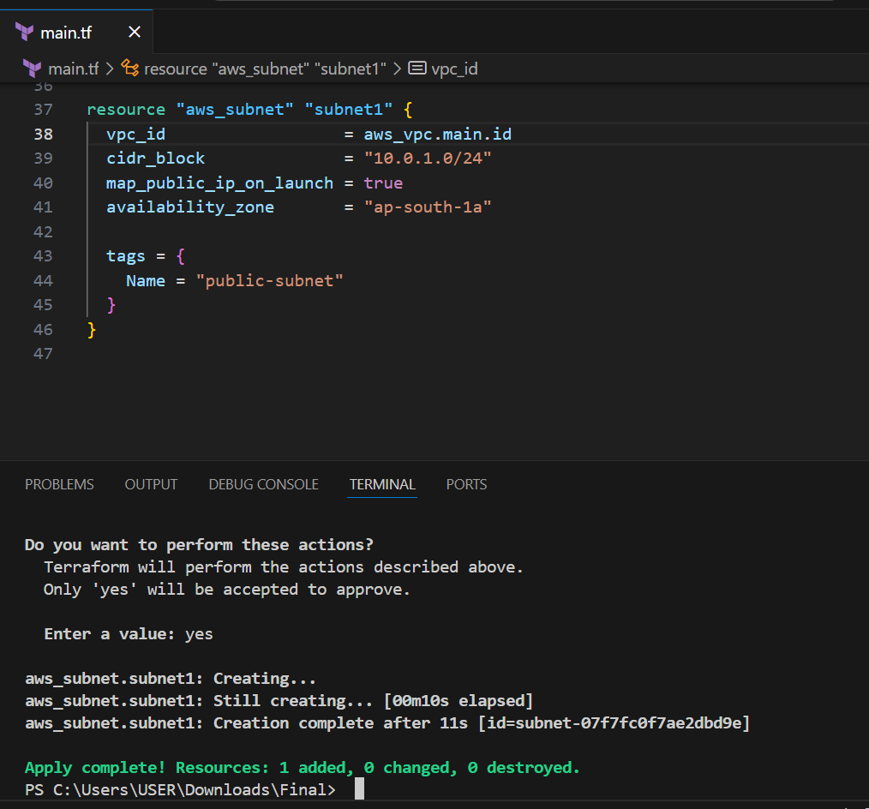

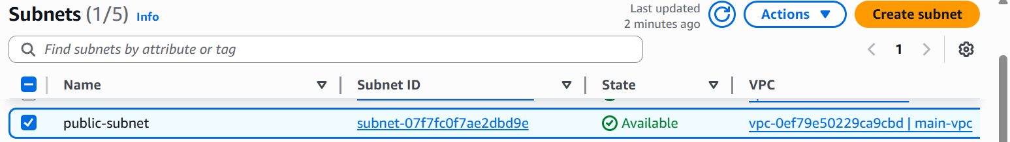

5.Associate subnet with Route Table

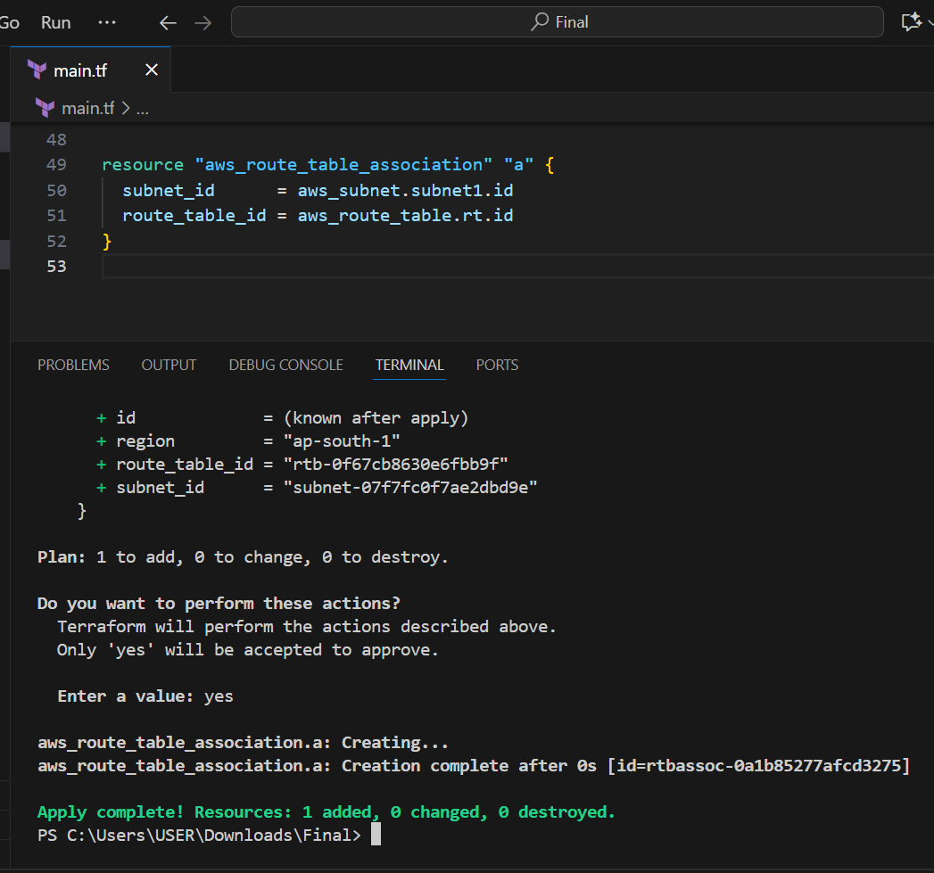

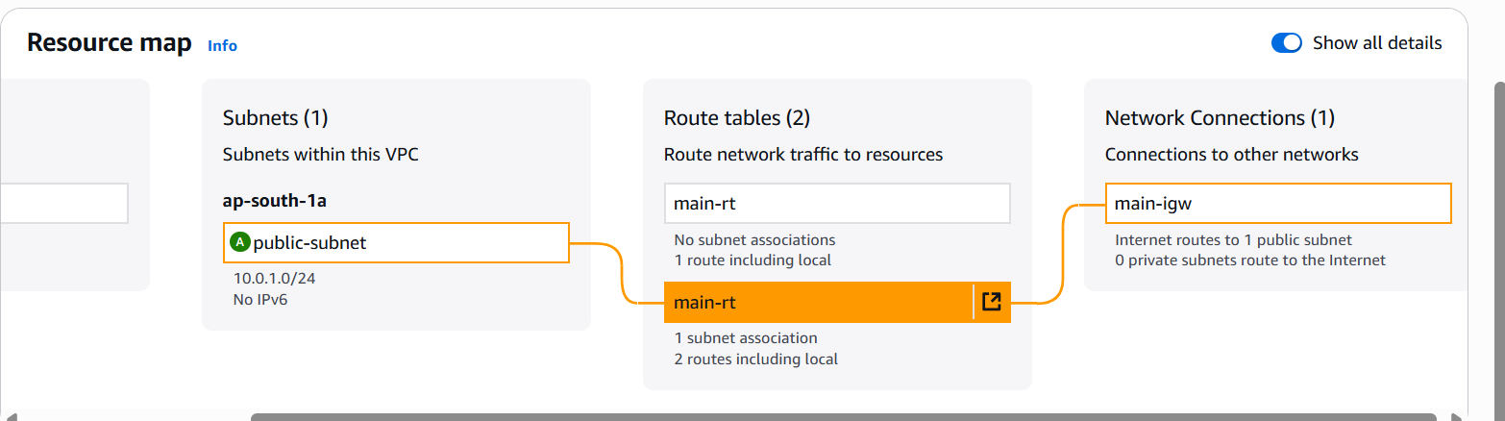

6..Create Security Group to allow port 22.80,443

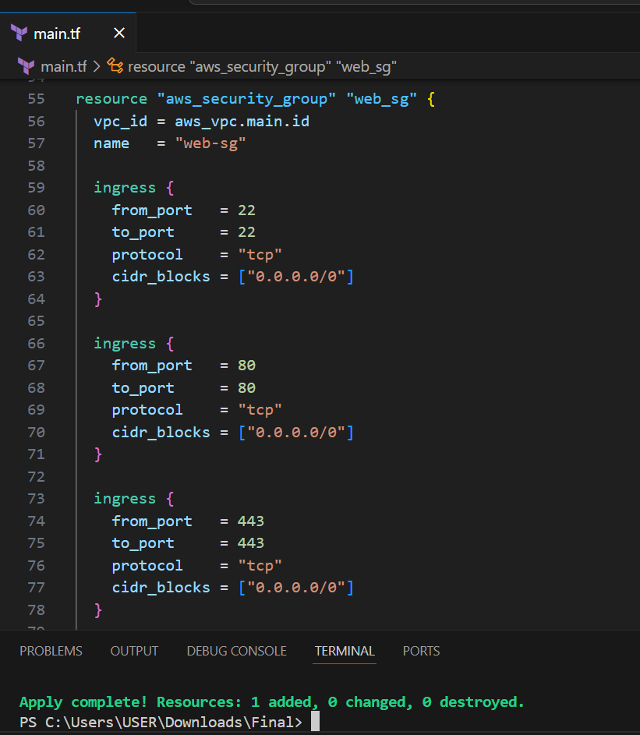

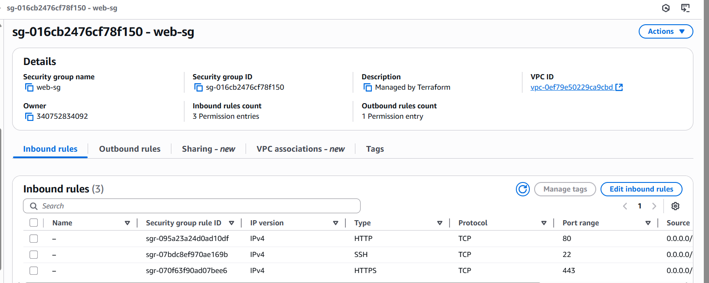

7.Create a network interface with an ip in the subnet that was created in step 4

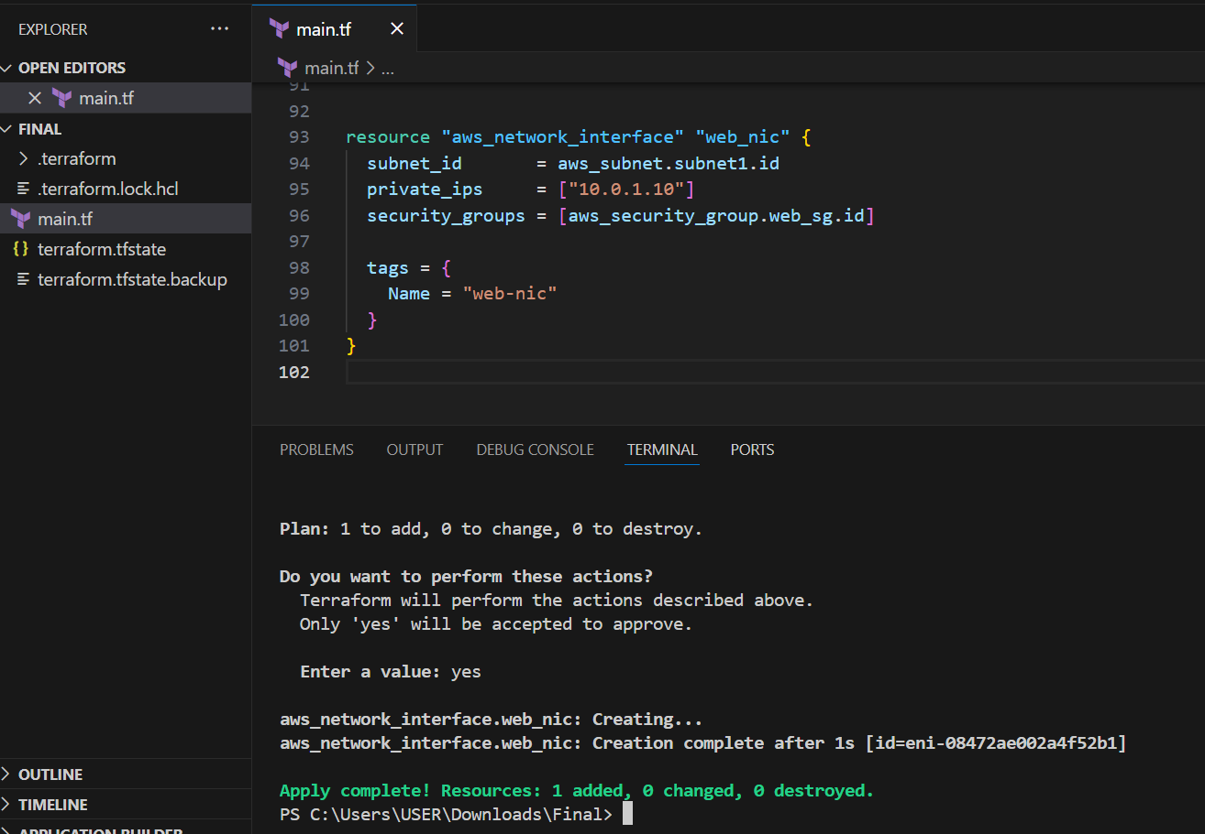

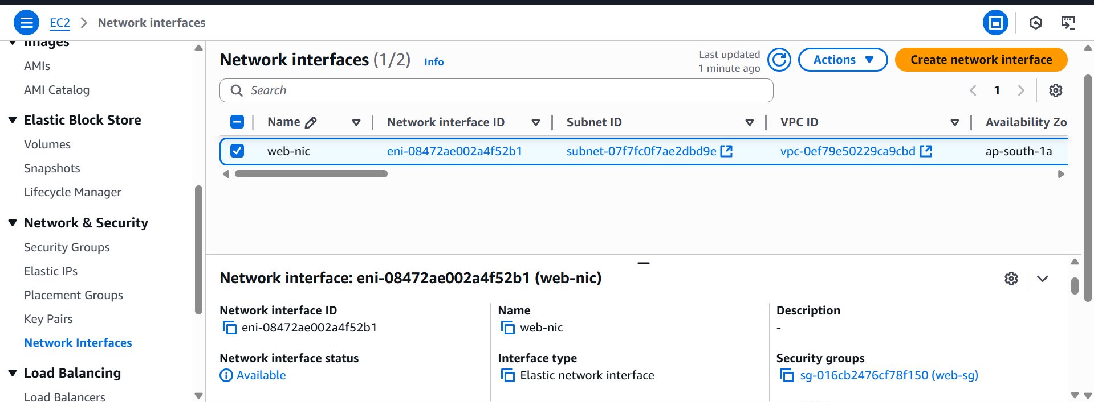

8.Assign an elastic IP to the network interface created in step7

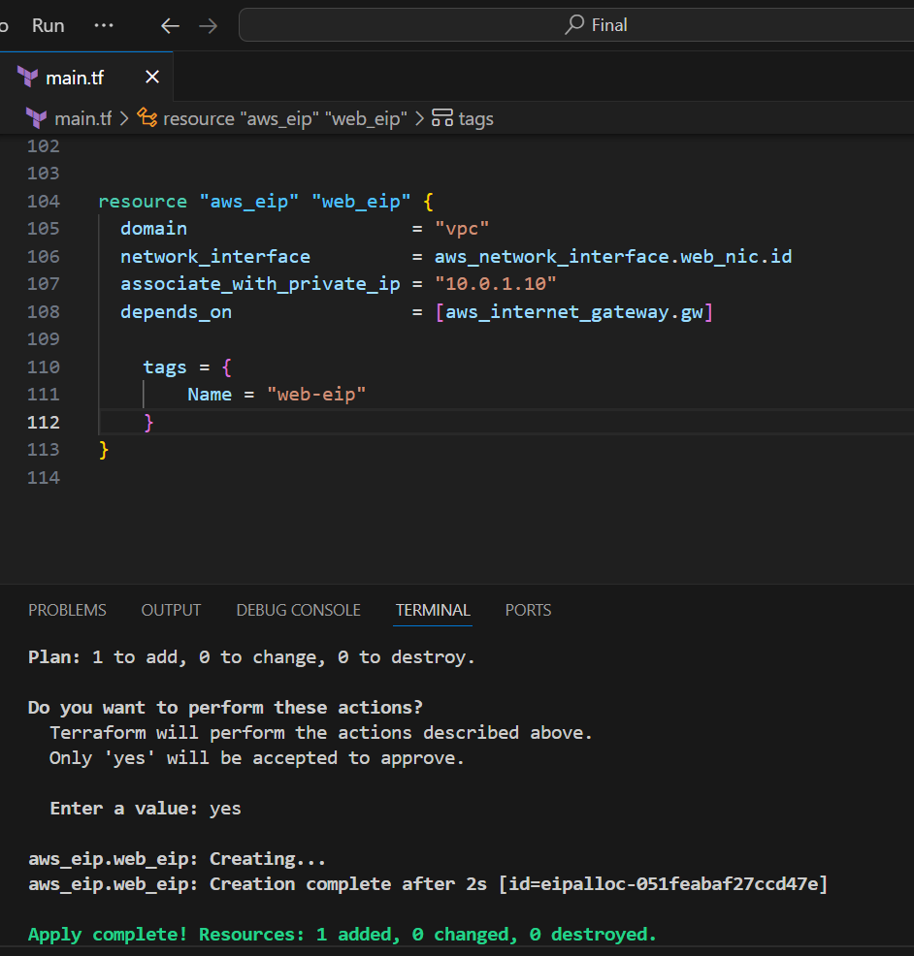

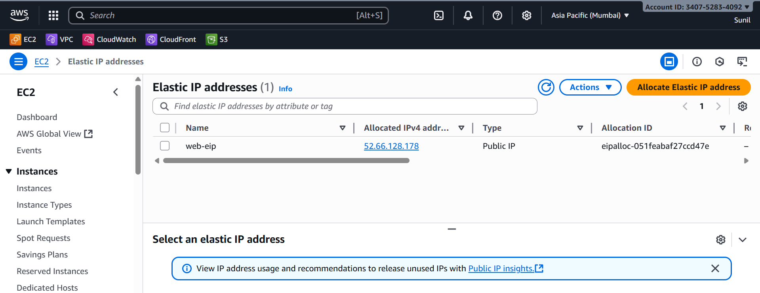

**9.Create Ubuntu server and install/enable apache2**

resource "aws_instance" "web" {

  ami           = "ami-02d26659fd82cf299"  # Ubuntu Server  ap-south-1

  instance_type = "t2.micro"

  key_name      = "jenkins"   # replace with your keypair

  subnet_id              = aws_subnet.subnet1.id

  vpc_security_group_ids = [aws_security_group.web_sg.id]

  user_data = <<-EOF

              #!/bin/bash

              apt-get update -y

              apt-get install apache2 -y

              systemctl start apache2

              systemctl enable apache2

              echo "<h1>Deployed via Terraform</h1>" > /var/www/html/index.html

              EOF

  tags = {

    Name = "ubuntu-server-"

  }

}

output "web_instance_public_ip" {

  value = aws_eip.web_eip.public_ip

}

